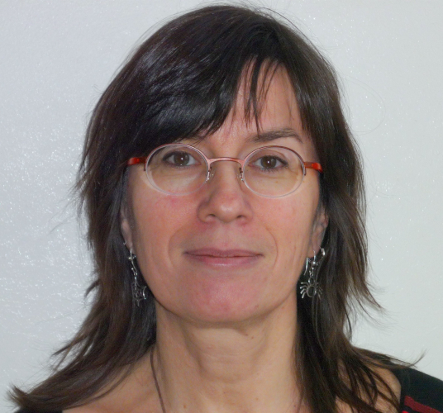

Annelies Braffort
CNRS Research Director
Research topics: Modelling and Automatic Processing of Sign Language, from corpus linguistics to artificial intelligence.
Research questions :
- How can sign languages be analysed, represented and processed ?
- How can we take into account the specific linguistic characteristics linked to their visual-gestural nature (multilinearity, spatialisation, iconicity)?
- What types of approach are possible with little French sign language (LSF) data?
Research work :
- Corpus of LSF: constitution, annotation, analysis
  - Nature of the data: video, motion capture (mocap)
  - Multidisciplinary studies: computer science (analysis and synthesis), linguistics, movement sciences, movement perception
- Linguistic modelling to represent the functioning of LSF
  - Levels: articulatory, gestural unit, more complex structures
  - Articulators: hands/arms, bust, shoulders, head, face, facial elements (eyebrows, eyes, cheeks, mouth), gaze
- Animation of virtual signers and generation of speech in LSF
  - Creation of animations by rotoscopy, mocap or synthesis
  - Generation of statements from predefined animations
- Analysis of LSF videos
  - Annotation assistance
  - Automatic recognition
Publications sur HAL - Corpora sur Ortolang.
Read more…

